WEST SOUND CORINTHIAN YACHT CLUB
Standard Sailing Instructions for Brownsville Races
Effective 1/1/2019

1. RULES
1.1. The race/regatta will be governed by the rules as defined in The Racing Rules of Sailing 2017-2020 (RRS).
1.2. All yachts shall comply with US Sailing Safety Equipment Requirements (SER), category “Nearshore”. These requirements are available at: https://www.ussailing.org/competition/offshore/safety-information/ser-world-sailing-special-regulations/
1.3. The Racing Rules of Sailing rules 35, A4.2, and A9 will be changed. The changes will appear in full in the Sailing Instructions or the Notice of Race NOR). Additional rules may be changed by the Notice of Race.
1.4. Pacific Handicap Racing Fleet - Northwest (PHRF-NW) handicapping rules shall apply. For handicap information, see web site www.phrf-nw.org .
1.5. The following Standard Rules and Racing Instructions shall apply to all races except as may be amended by individual Notice of Race.
1.6. Interference with Traffic: Interference with non-racing traffic is strictly forbidden. A report of interference by the traffic to the Race Committee is sufficient cause for protest. No sounds are required.
1.7. Yachts shall not approach within 100 yards of any US naval vessel. If you need to pass within 100 yards of a U.S. naval vessel in order to ensure a safe passage, you must contact the U.S. naval vessel or the Coast Guard escort vessel on VHF-FM channel 16.
- ENTRIES
1.8. See Notice of Race. Late entries may be accepted at the discretion of the Race Committee.
- NOTICES TO COMPETITORS
1.9. Notices to competitors will be posted on the official notice board located at the Committee Boat.
- SIGNALS MADE ASHORE
1.10. No signals will be made ashore. All signals will be from the Committee Boat or Marina breakwater.

5. SCHEDULE and CLASS FLAG(S)
1.11. The scheduled time of the warning signal for the first race will be given in the Notice of Race.
1.12. The class (division) flags are:
Class | PHRF-NW Rating | Division Flag
1 | 140 and under | signal pennant 1 (white with a red dot)
2 | 141 and over | signal pennant 2 (blue with a white dot)
3 | No Flying Sails (NFS) | signal pennant 3 (vertical red, white, and blue)
1.13. The order of starts is given in the Notice of Race.
1.14. Number of races is given in the Notice of Race.
6. RACING AREA
1.15. The racing area will be Port Orchard Bay

7. COURSE[S] and MARKS
1.16. The courses:
Course | Marks  *(“S” start order, reverse order for “N” start) | Distance (nm)
A | 1-2-3-1* | 3.44
B | 1-2-4-1* | 7.62
C | 1-4-1* | 6
D | WINWARD/LEEWARD (marks to port) | Determined by RC
J | Get Course from RC | Determined by RC
  - DESCRIPTION OF MARKS
    - Courses A, B, C Mark Description. See figure 1 in section 17chartlet.
Mark | Mark Description
1 | Club buoy (start line) set off the Brownsville Marina breakwater or committee boat
2 | Club Buoy Set off of University Point
3 | Club Buoy Set off of Battle Point
4 | #6 "dolphin” NE of Point Bolin
    - Mark rounding courses A, B, and C.
“N” placard = north start and leave all rounding marks to STARBOARD.
“S” placard = South start and leave all rounding marks, PORT.
    - For course D, three club buoys will be used for the start pin, windward mark, and leeward mark. The start/finish line is “open” and may be crossed during the race. For course D, leave all rounding marks to PORT. See figure 2 in section 17 chartlet for course diagram.
  - The Race Committee will display the course, number of laps, and course direction. The Race Committee may select multiple courses. The crossing of the finish line for the first lap is considered to be the start of the second lap.

Example courses:
RC Display | Interpretation of RC Display | Marks and Rounding Direction | Distance (nm)
A1S | Course A, 1 lap, South Start | 1p, 2p, 3p,1p | 3.44
A1N | Course A, 1 lap, North Start | 1s, 3s, 2s,1s | 3.44
A2S | Course A, 2 laps, South Start | 1p, 2p,3p,1p,2p,3p,1p | 6.88
A2N | Course A, 2 laps, North Start | 1s, 3s, 2s, 1s, 3s, 2s ,1s | 6.88
B1S | Course B 1 lap South Start | 1p, 2p, 4p,1p | 7.62
B1N | Course B 1 lap North Start | 1s, 4s, 2s,1s | 7.62
C1N | Course C1 lap North Start | 1s, 4s,1s | 6

8. THE START
1.23. The starting line will be between a staff displaying an orange flag at the committee and an orange club buoy at the other end.

10. THE FINISH
1.24. The finish line will be between a staff displaying an orange flag at the committee and an orange club buoy at the other end.

11. TIME LIMIT
1.25. See NOR for the applicable time limit.
1.26. Racers who withdraw before finishing shall notify the Race Committee at the earliest opportunity. In a multiple race regatta, racers who finish a race and decide to retire from racing shall notify the Race Committee at the earliest opportunity.

12. USE OF ENGINE
1.27. Engines shall not be used except as necessary to avoid non-racing traffic or to aid in the rescue of a boat or
crew. The yacht’s skipper shall report (in writing) all details to the protest committee (see 14), which may then give redress. Note: starting the engine in advance of a possible danger but not placing it in gear, does not relieve the yacht for the reporting requirements. This states the circumstances where propulsion is permitted as required in RRS Rule 42.3(h).

13. ALLOWED RADIO COMMUNICATION
1.29. A BOAT MAY CONTACT Navy, commercial or private traffic to confirm that they are not going to interfere with that traffic in the foreseeable future. Such communications may only be used to ascertain what action the traffic would like the boat to accomplish. Use channels 13, 14 and 16 as appropriate.

14. PROTESTS
1.30. The Race Committee shall be notified as soon as possible of the intent to protest. Protests shall be delivered to race committee within one hour after the last boat finishes.

15. SCORING
1.31. Scoring system and number of excluded races are given in the Notice of Race unless the RRS provides the correct information.
1.32. For each race, a boat that did not finish (DNF) shall be scored points for the finishing place one more than the number of boats that finished. A boat that was disqualified (DSQ) or did not start (DNS) shall be scored points for finishing place one more than the number of starters for that race. A boat that did not compete (DNC) shall be scored points for finishing place one more than the number of series starters. This changes RRS A4.2 and A9.
cha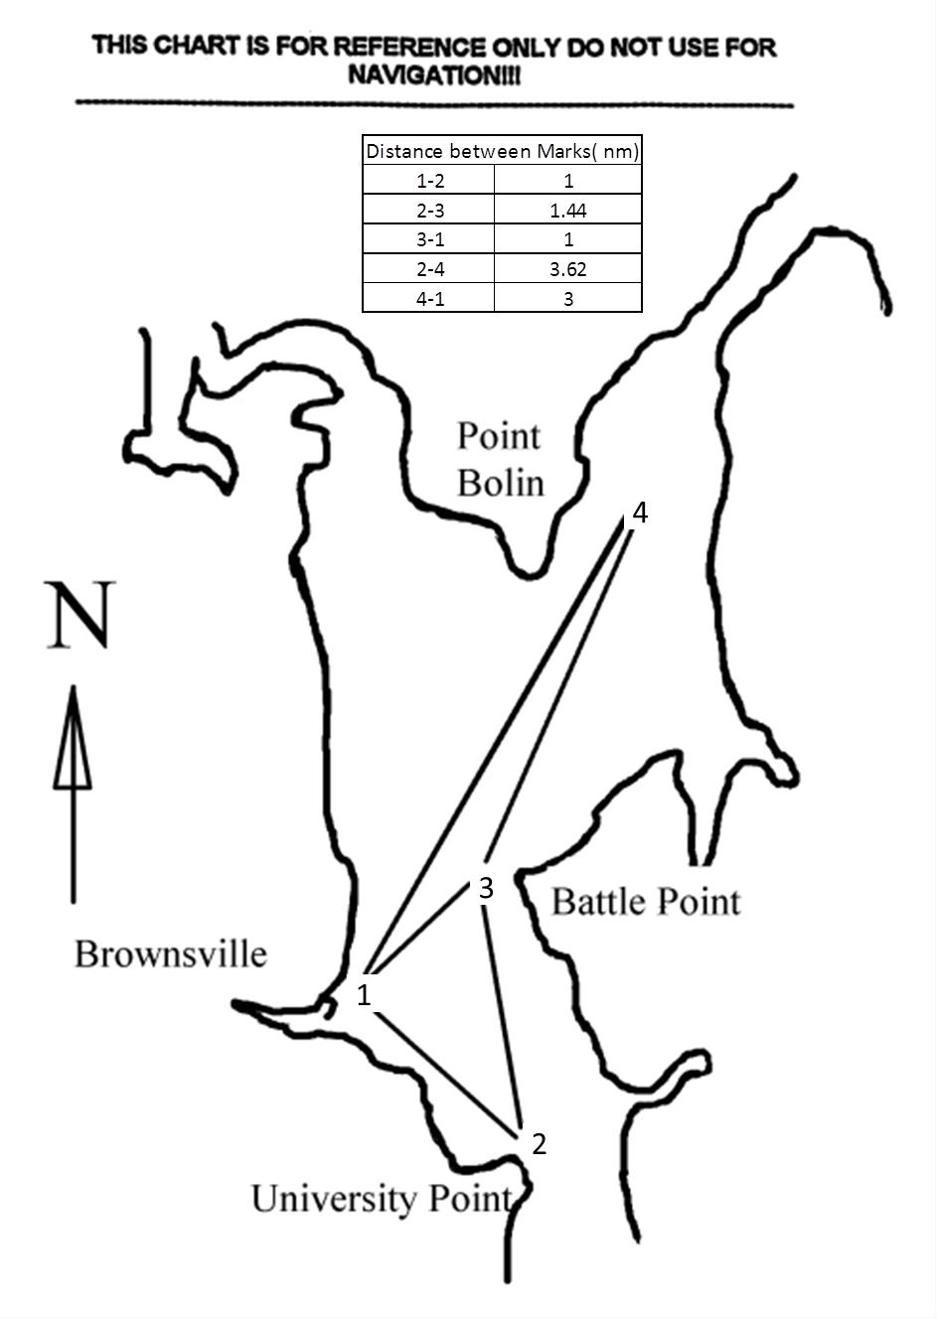rule changes Rule A4.2 and Rule A9.

Committee boat or dock
Start pin
Windward mark
Leeward mark
Start
/
finish

